Swiggy Food Delivery Data Engineering Project
Using Microsoft Fabric

1. Objective
The objective of this project is to design and implement an end-to-end data engineering solution using Microsoft Fabric, starting from raw data ingestion to business insights generation.

2. Architecture Overview
The project follows a Medallion Architecture:
Bronze → Raw Data
Silver → Cleaned Data
Gold → Business-ready Data
Data Flow:
CSV → Lakehouse → Notebook → Delta Table → Pipeline → Data Warehouse → Star Schema → SQL Analysis
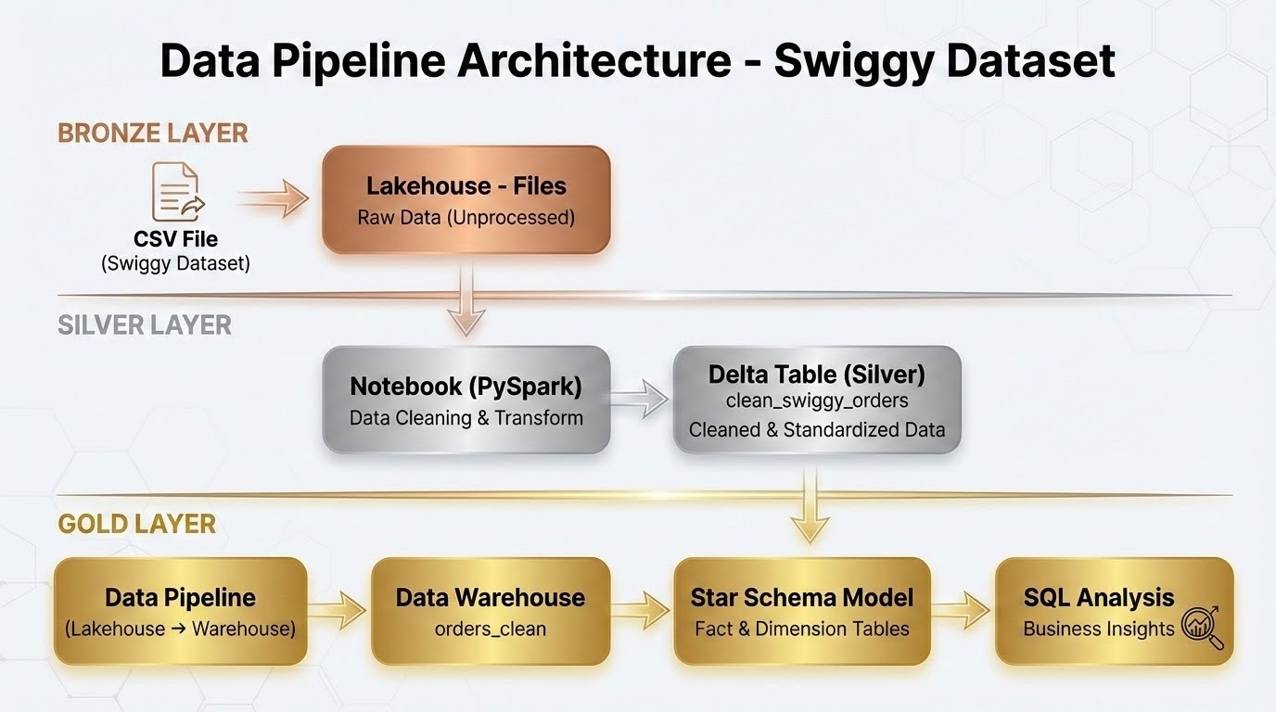

3. Data Ingestion
- Loaded Swiggy dataset (CSV) into Fabric Lakehouse (Files section)
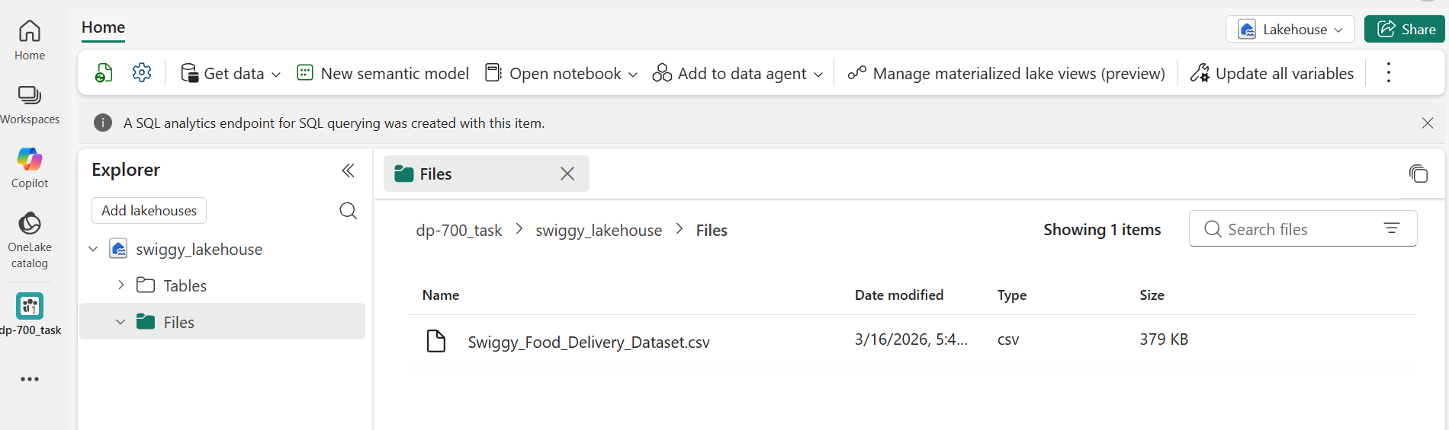
- Accessed data using PySpark notebook
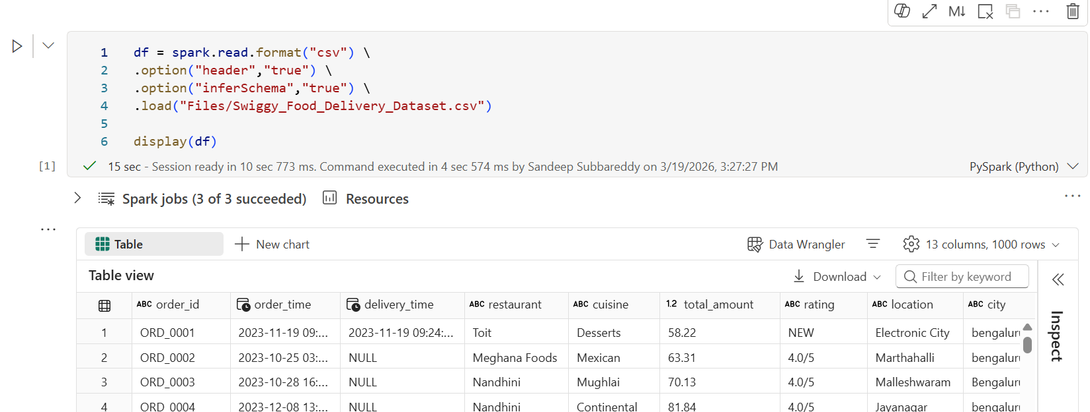

4. Data Cleaning & Transformation
Performed data cleaning using PySpark as per requirements
Handling Missing Values
- Replaced null values in categorical columns with "Unknown"
- Handled missing numeric values using default values
String Standardization
- Applied trim(), initcap(), regexp_replace()
- Corrected inconsistent city names
Rating Transformation
- Converted rating from string format (e.g., "4.5/5") to numeric
- Created rating_numeric column
Data Validation
- Ensured total_amount contains only positive values
Conditional Logic
- Set delivery_time and distance_km to NULL when online_order = 'No'

5. Delta Table Creation
- Stored cleaned data in Lakehouse as Delta table:
clean_swiggy_orders
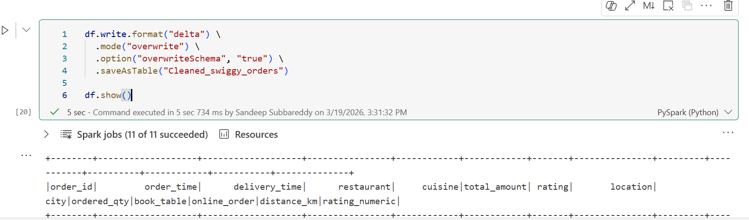

6. Data Pipeline
- Created a data pipeline to move cleaned data from Lakehouse to Data Warehouse
- Used Copy Activity for data transfer
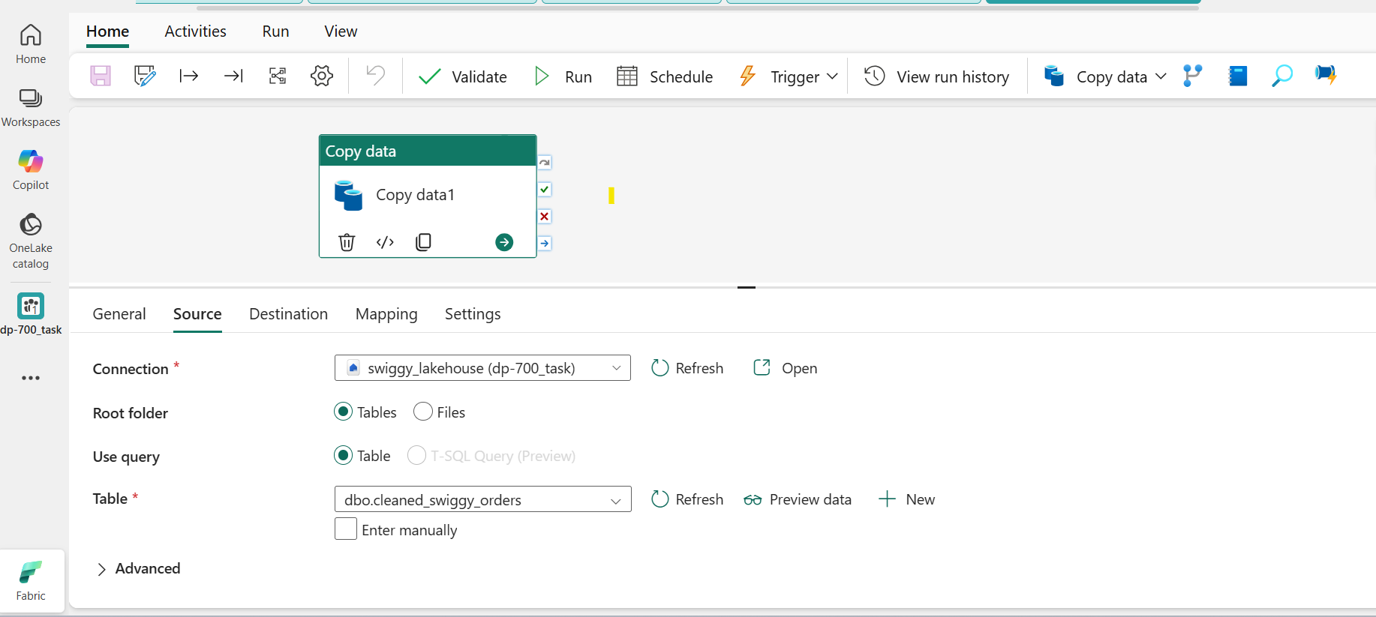

7. Data Warehouse
- Loaded cleaned data into Fabric Data Warehouse
- Created structured table:
cleaned_data
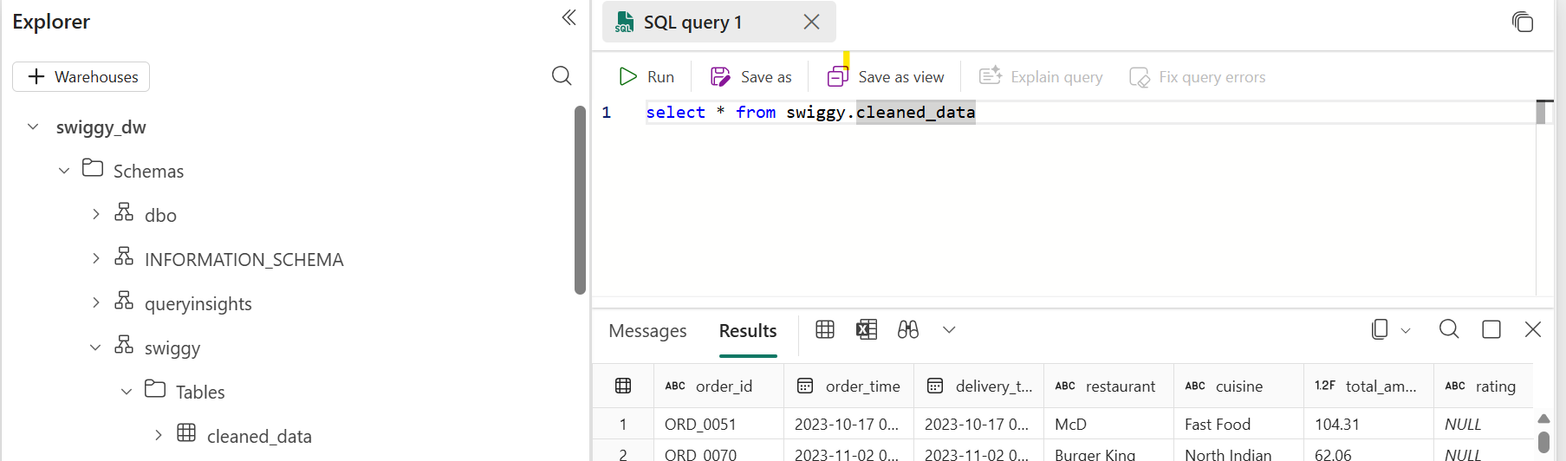

8. Data Modeling (Star Schema)
Fact Table
Fact_Orders
- order_id
- restaurant_key
- location_key
- time_key
- total_amount
- ordered_qty
- distance_km
- rating_numeric
Dimension Tables
Dim_Restaurant
- restaurant_key
- restaurant_name
- cuisine_type

Dim_Location
- location_key
- area_name
- city_name
Dim_Time
- time_key
- full_timestamp
- hour
- day_name
- is_weekend
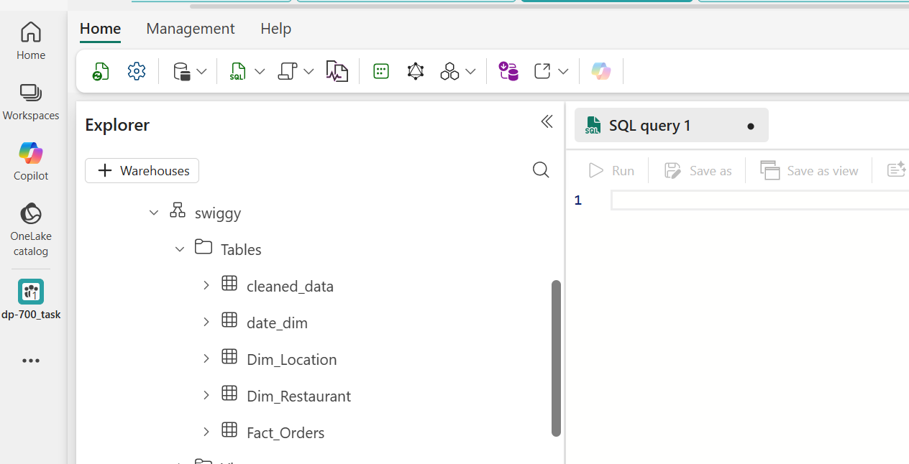

9. Data Analysis
Performed SQL-based analysis as per business requirements
Category: Sales & Revenue
- What is the total revenue generated across all orders?
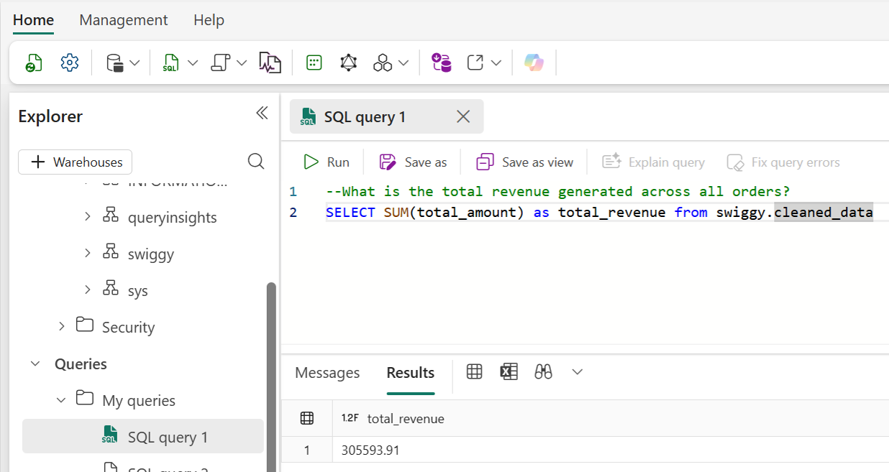

- Which are the top 5 cuisines by total revenue?
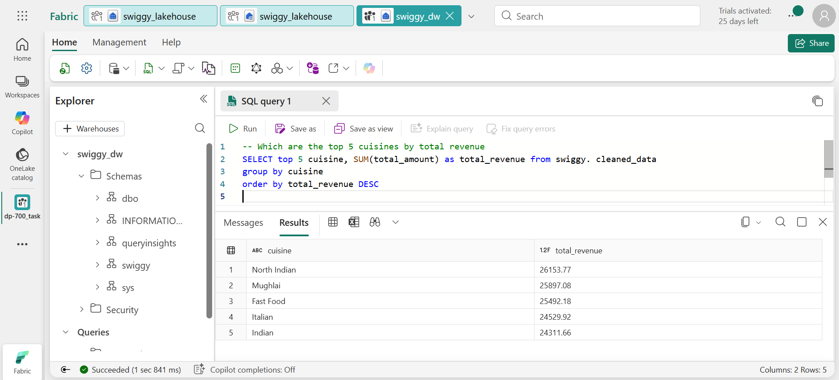

- Which area in Bengaluru generated the highest sales?
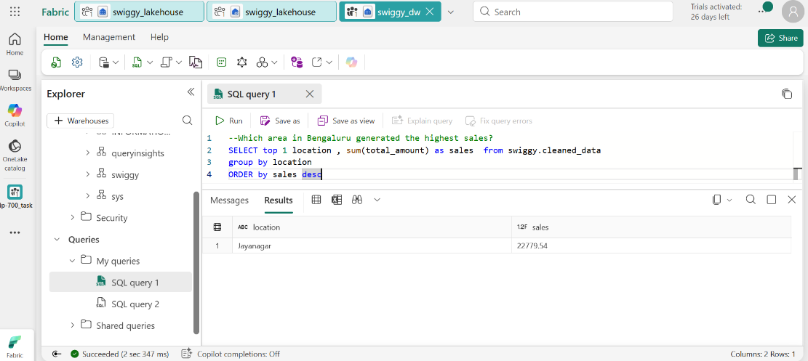

- What is the average order value (AOV)?
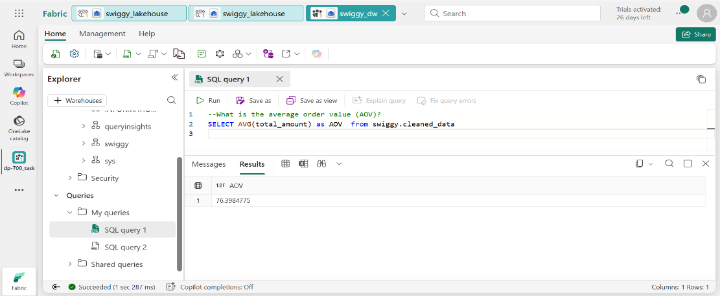
- List the top 10 orders with the highest total_amount.
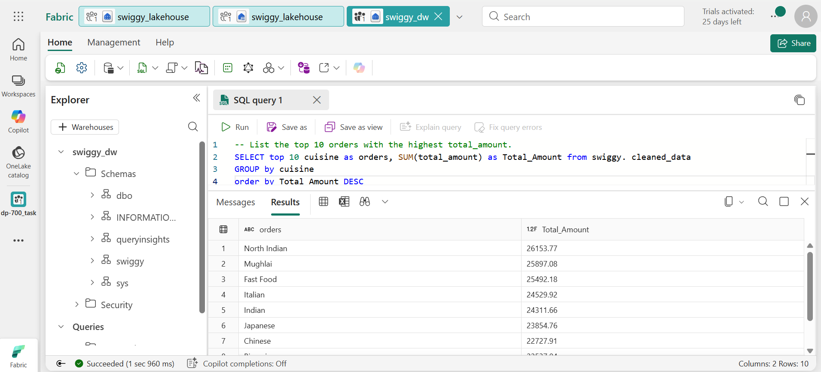

Category: Operational Efficiency
- What is the average delivery time (in minutes) for all online orders?
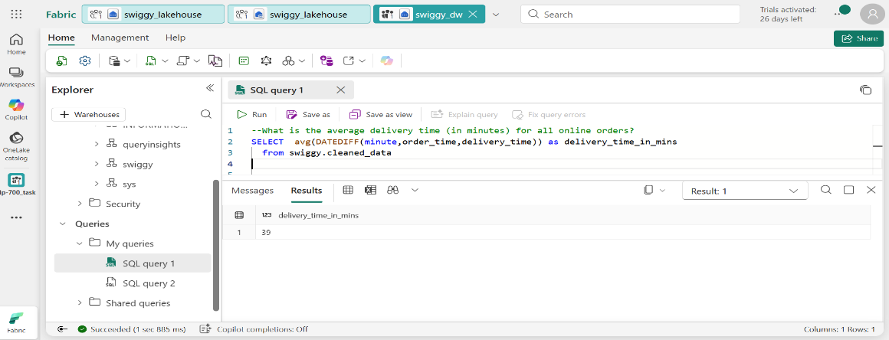

- Which 5 restaurants have the fastest average delivery time?
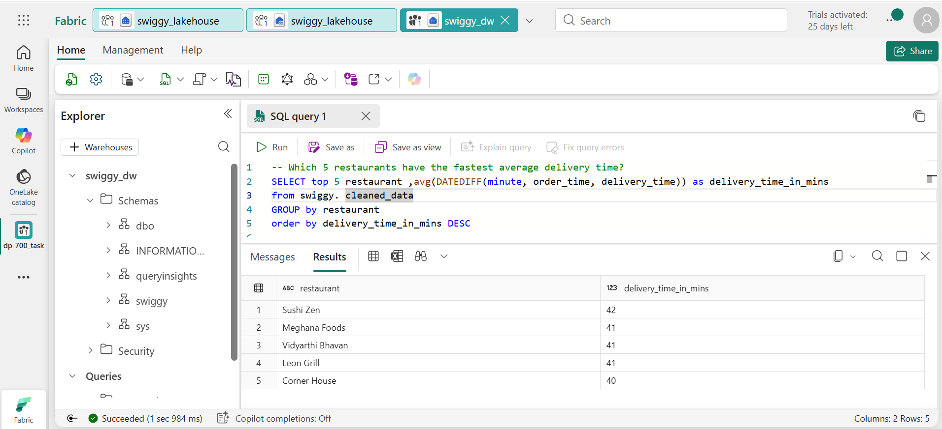
- Which location has the highest average delivery time?
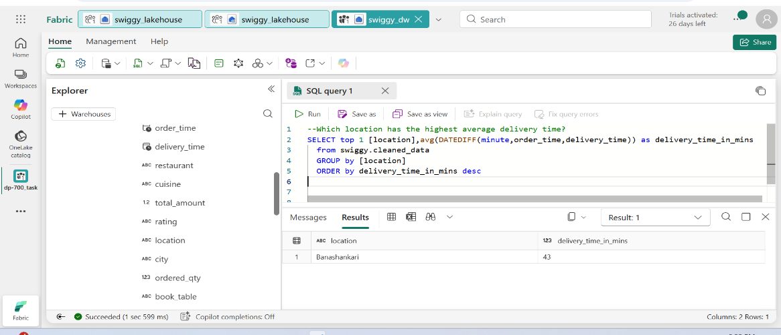

- What is the average delivery time for orders with distance > 10 km?
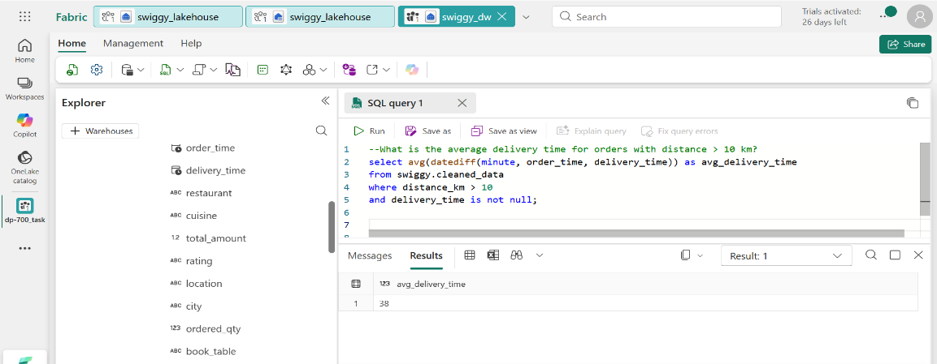
- Delivery Success Rate: How many orders have a valid delivery_time compared to the total online_order = 'Yes' count?
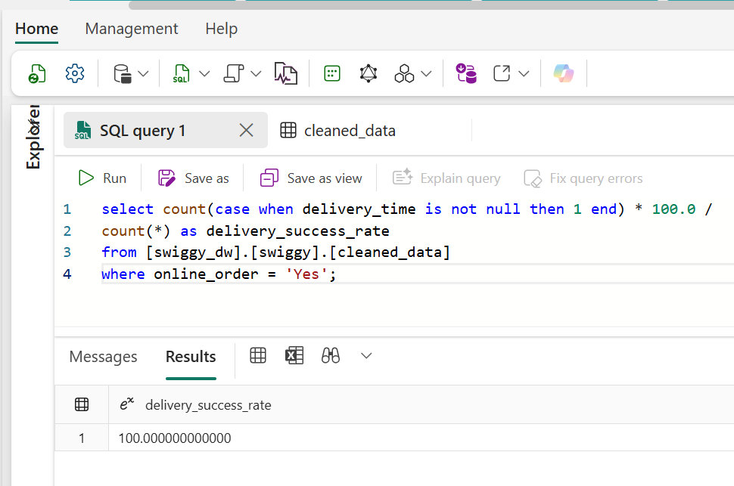
Category: Customer Behavior
- What is the percentage split between Online vs Offline orders?
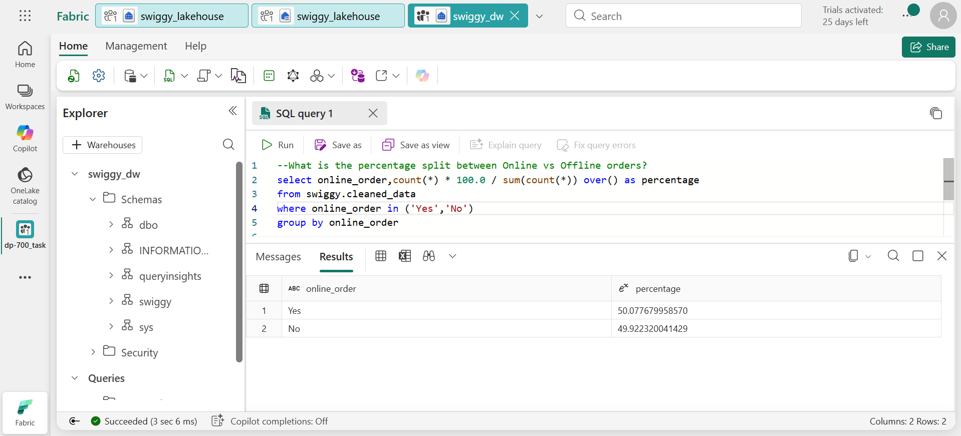
- Do customers who book a table spend more on average than those who don’t?
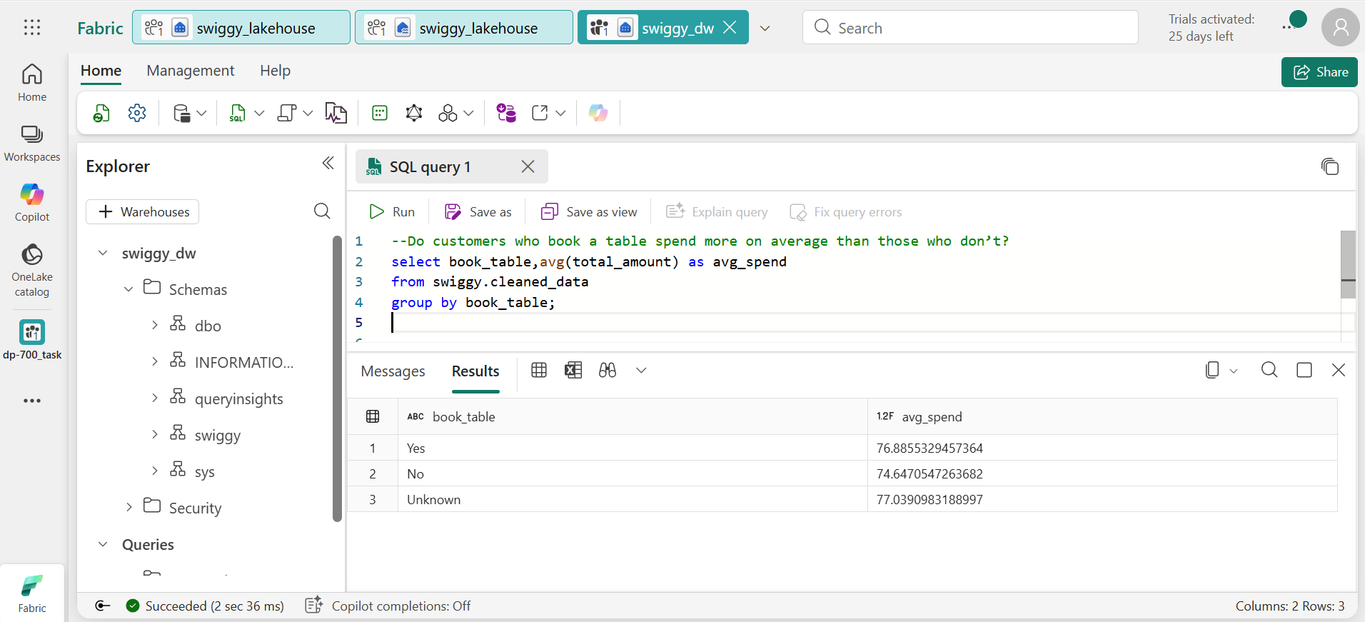
- During which hour of the day do most orders occur?
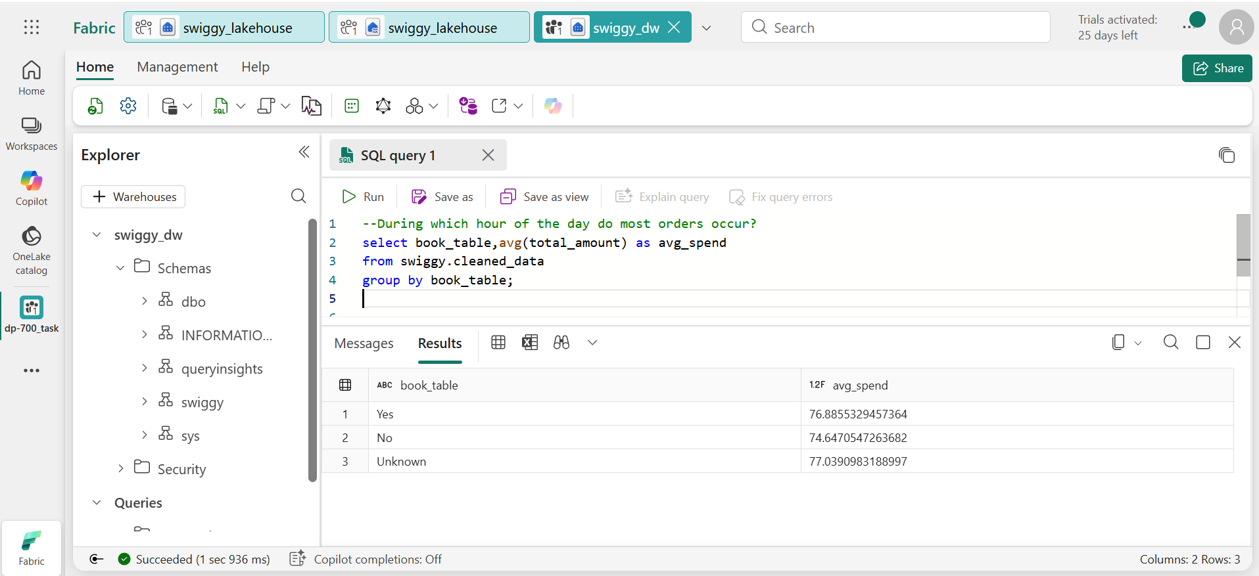

- Which 5 locations have the highest number of orders?
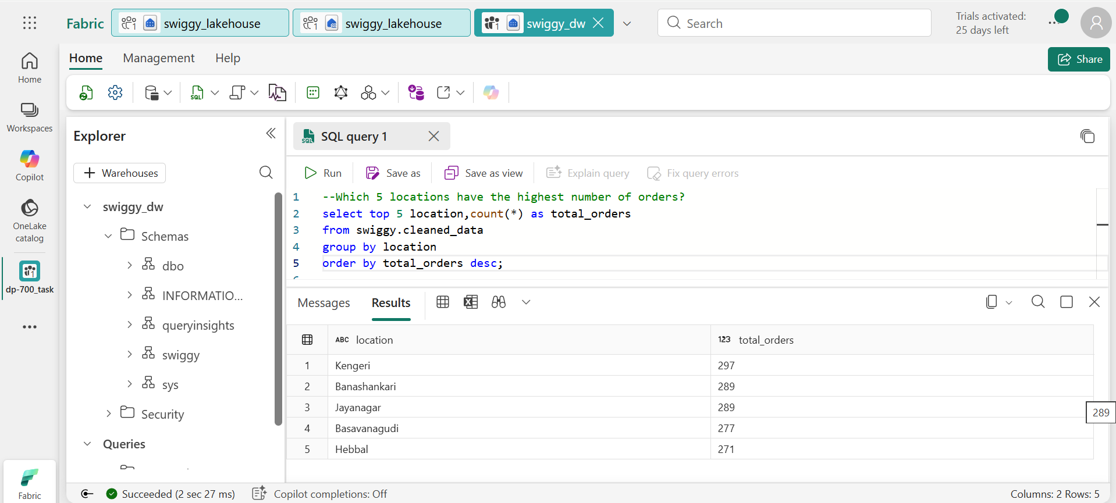

- What is the average ordered quantity per cuisine type?
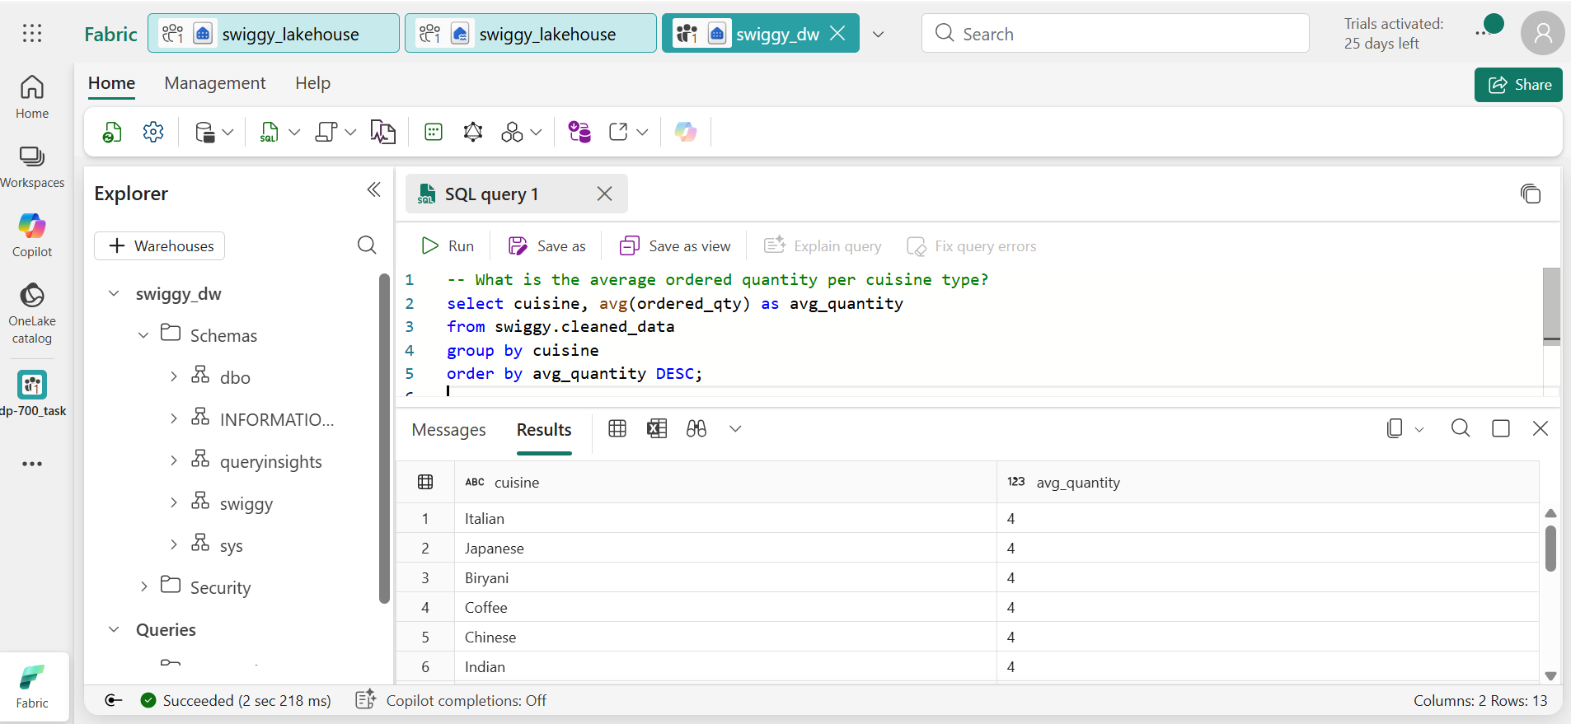
Category: Quality & Ratings
- Which restaurants have an average rating > 4.5?
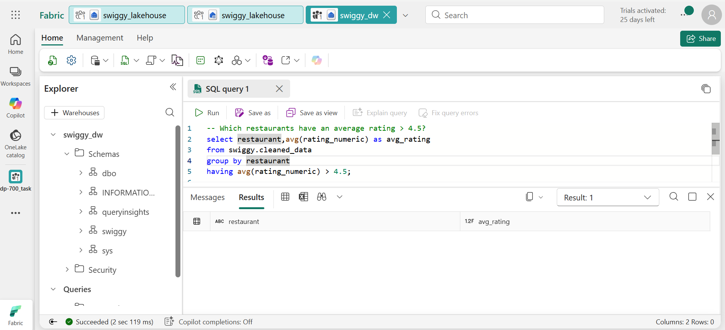
- Which cuisine has the highest average rating?
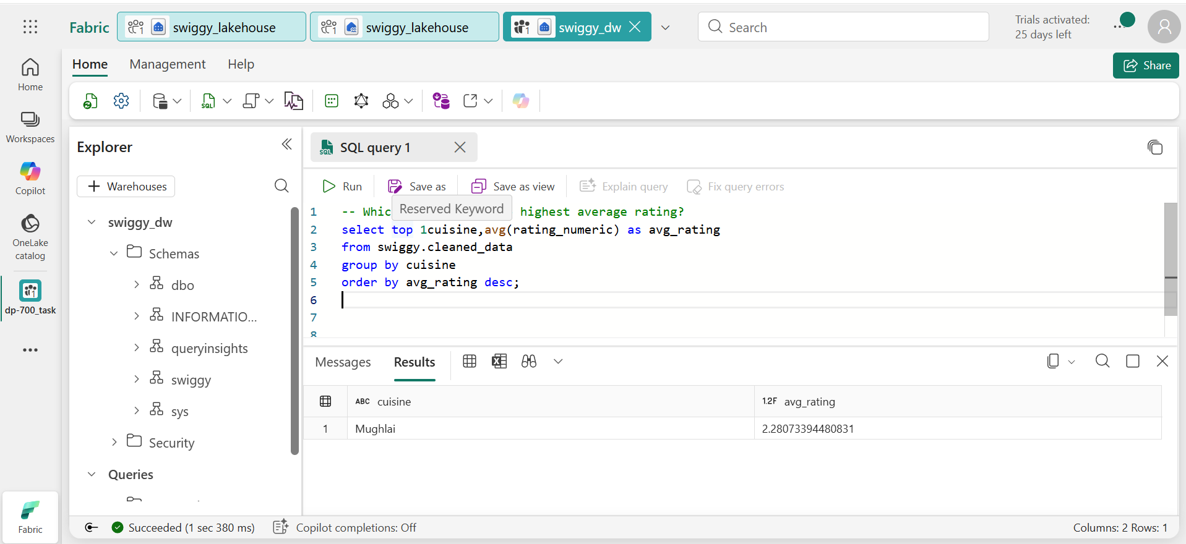

- Is there a correlation between total_amount and rating?
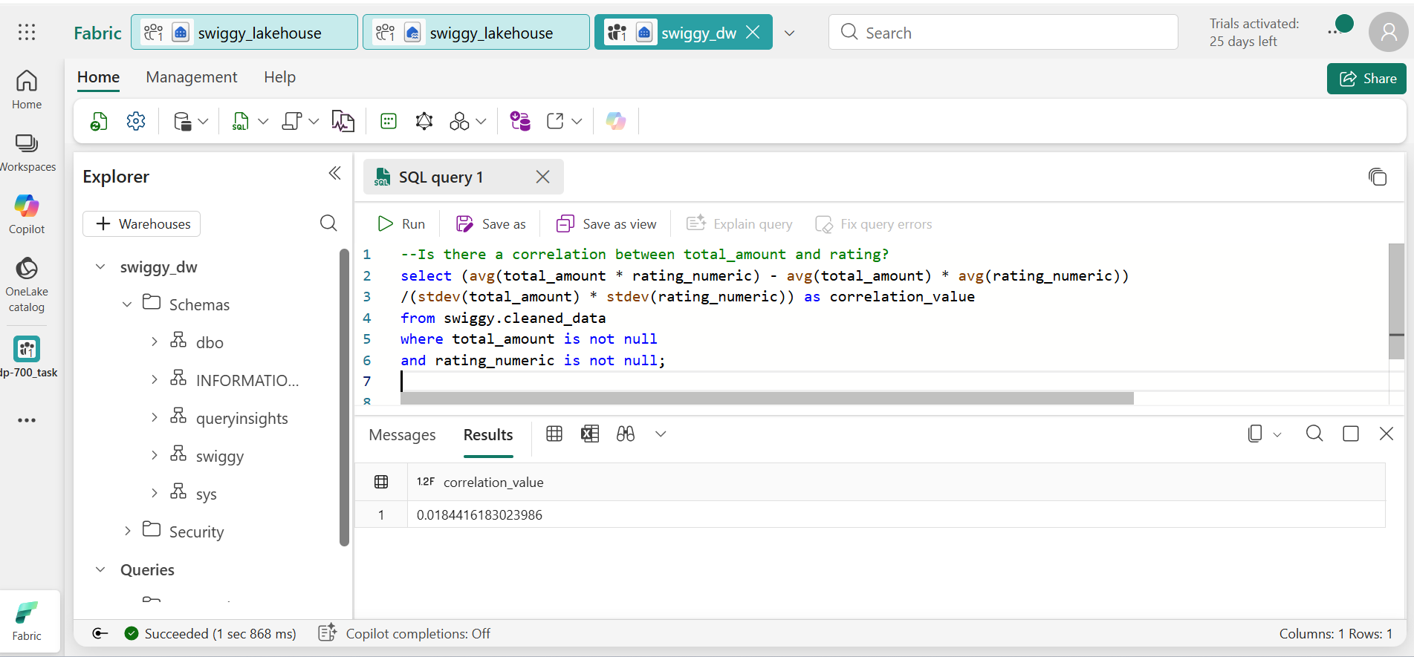
- List restaurants with more than 10 orders AND avg rating < 3.0. 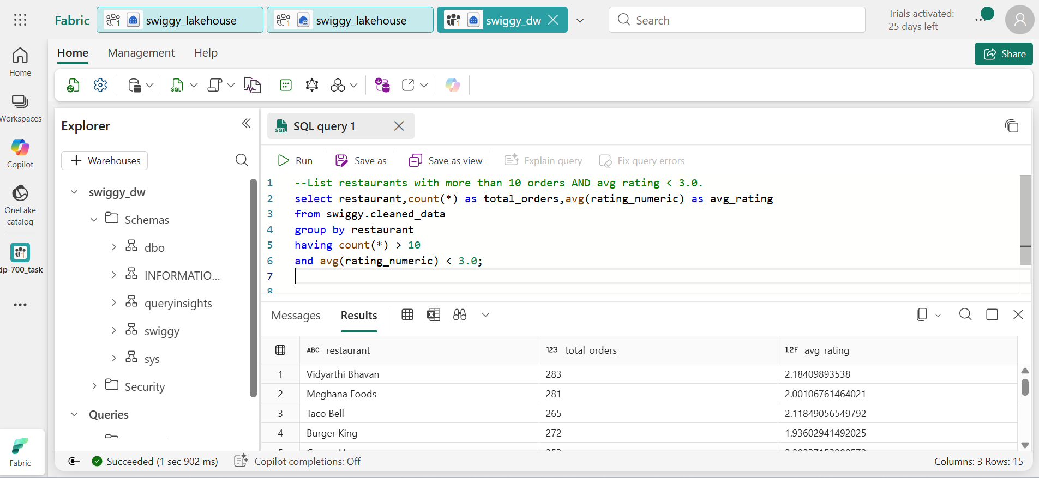

- What is the average rating across Bengaluru?
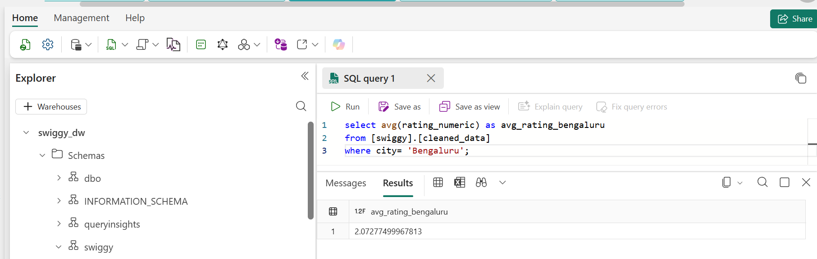

10. Conclusion
This project demonstrates a complete data engineering lifecycle including data ingestion, transformation, pipeline orchestration, data modeling, and analytical reporting using Microsoft Fabric.

11. Tools & Technologies
- Microsoft Fabric
- PySpark
- SQL
- Delta Lake

